**CRM Guide: Payables to Landlords**

Finance → Payables

*A step-by-step visual guide to processing landlord payments*

# **Overview**

The Payables section of the CRM allows you to process rent payments owed to landlords after deducting management fees and other charges. There are two main workflows:

* Method 1 – Payables to Landlords: Pay landlords individually, one property at a time. Best for straightforward single-property landlords.
* Method 2 – Payables to Landlord Consolidated: Grouped view for landlords with multiple properties. Allows partial payments per property and batch EFT/BACs processing.

Both methods result in a landlord payment being recorded and a remittance advice statement being generated. The EFT to process tab is shared by both methods for bulk BACs payments.

# **Method 1: Payables to Landlords**

Use this method to process payments for individual landlords. Each row in the list represents one landlord and one property. The page shows all landlords with outstanding balances by default.

**Step 1: Navigate to Finance → Payables → Payables to Landlords**

From the left-hand menu, click Finance → Payables. The Payables to Landlords tab will be selected by default. The page shows a list of all landlords with outstanding statement balances, including the last payment date, due date, statement balance, money withheld, and amount to pay.

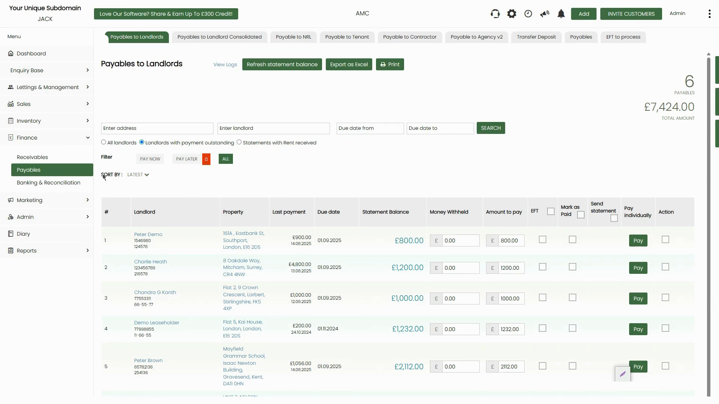

*Figure 1: Payables to Landlords page — 6 landlords with a total of £7,424.00 outstanding*

**Step 2: Understand the Page Filters and Columns**

Use the filter options at the top to narrow down the list:

* All landlords – Shows every landlord regardless of balance.
* Landlords with payment outstanding – Shows only landlords who have money to be paid (default view).
* Statements with Rent received – Shows landlords where rent has been received.

The PAY NOW / PAY LATER / ALL filter buttons (below the radio buttons) let you further filter by payment urgency. The orange badge on PAY LATER shows the number of payments deferred. Key columns are Statement Balance (amount owed to the landlord), Money Withheld (fees/charges held back), and Amount to pay (editable field for the payment amount).

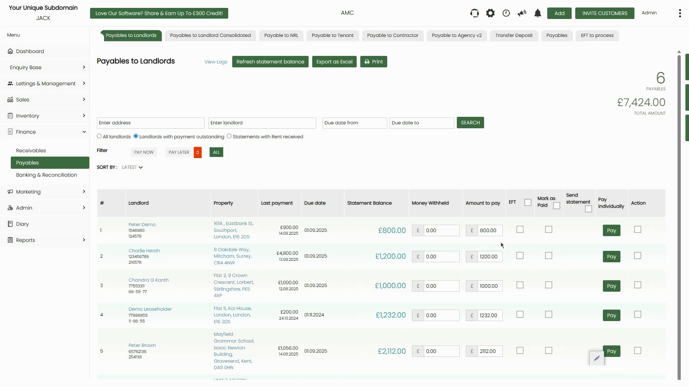

*Figure 2: Filter options and column layout — Statement Balance shown in green, Amount to pay is editable*

**Step 3: Adjust the Amount to Pay (Optional)**

The Amount to pay field is pre-filled with the full outstanding balance. You can manually edit this field to pay a partial amount if needed. The Money Withheld field can also be edited to withhold additional funds before making the payment.

**📌 Note:** If a landlord's statement balance shows a negative amount (e.g. they owe money due to charges exceeding receipts), the system will still display the row but you should set the Amount to pay to 0 and investigate before processing.

**Step 4: Choose a Payment Method — Pay, Mark as Paid, or EFT**

Each landlord row has three payment options on the right:

* Pay button (green) – Opens the Mark as paid dialog to record a payment immediately.
* Mark as Paid checkbox – Tick to mark without going through a payment dialog (for manual/offline payments).
* EFT checkbox – Adds the landlord to the EFT to process queue for BACs batch payment.
* Send statement checkbox – Tick to automatically send a remittance advice to the landlord when payment is processed.
* Pay individually checkbox – Used in Consolidated view; allows paying one property separately.

**Step 5: Click 'Pay' and Complete the Mark as Paid Form**

Clicking the Pay button opens the Mark as paid dialog. The right side of the dialog shows a statement history table for the landlord, listing all transactions (rent receipts, payments, charges). Review this before proceeding. If any transactions are not yet reconciled, the system will display a warning and a confirmation button.

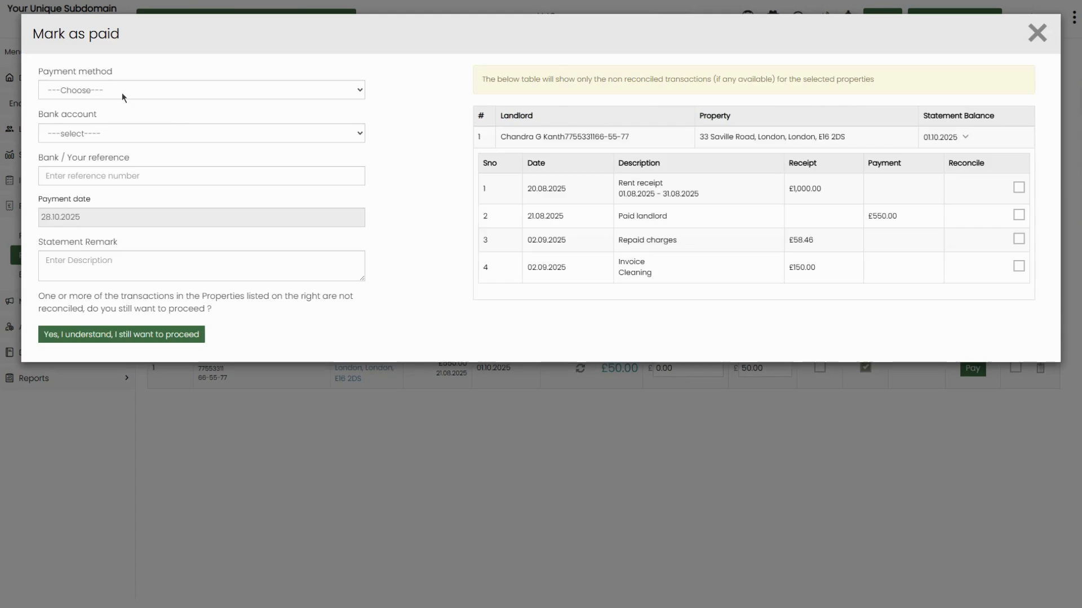

*Figure 3: Mark as paid dialog — left side for payment details, right side shows landlord statement history with unreconciled transactions warning*

Complete the fields on the left:

* Payment method – Select the payment method (Bank Transfer, BACs Transfer, Cheque, Cash, etc.).
* Bank account – Select the client bank account the payment is drawn from.
* Bank / Your reference – Enter a payment reference (e.g. 'Oct payment').
* Payment date – Enter the date of payment.
* Statement Remark – Enter a description that will appear on the landlord's statement.

**⚠️ Important:** If the system shows unreconciled transactions, click 'Yes, I understand, I still want to proceed' to confirm and continue. This means some bank transactions have not yet been reconciled but the payment can still be processed.

**Step 6: Process via EFT/BACs Instead (Alternative)**

If you prefer to process payments via BACs file rather than recording them individually, tick the EFT checkbox next to each landlord you want to include. This adds them to the EFT to process queue.

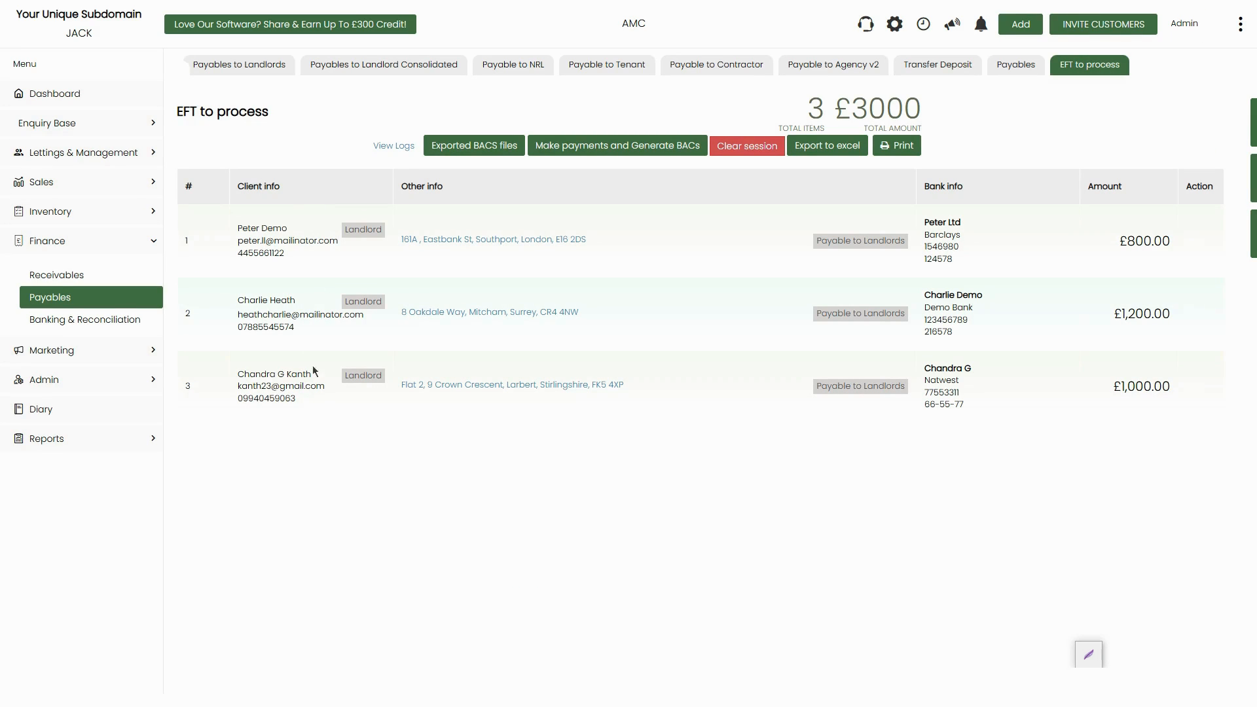

*Figure 4: EFT to process tab — 3 landlords queued for BACs payment totalling £3,000*

Navigate to the EFT to process tab (top navigation). This shows all landlords added to the EFT queue, with their bank details and amounts. Click Make payments and Generate BACs to open the payment confirmation dialog.

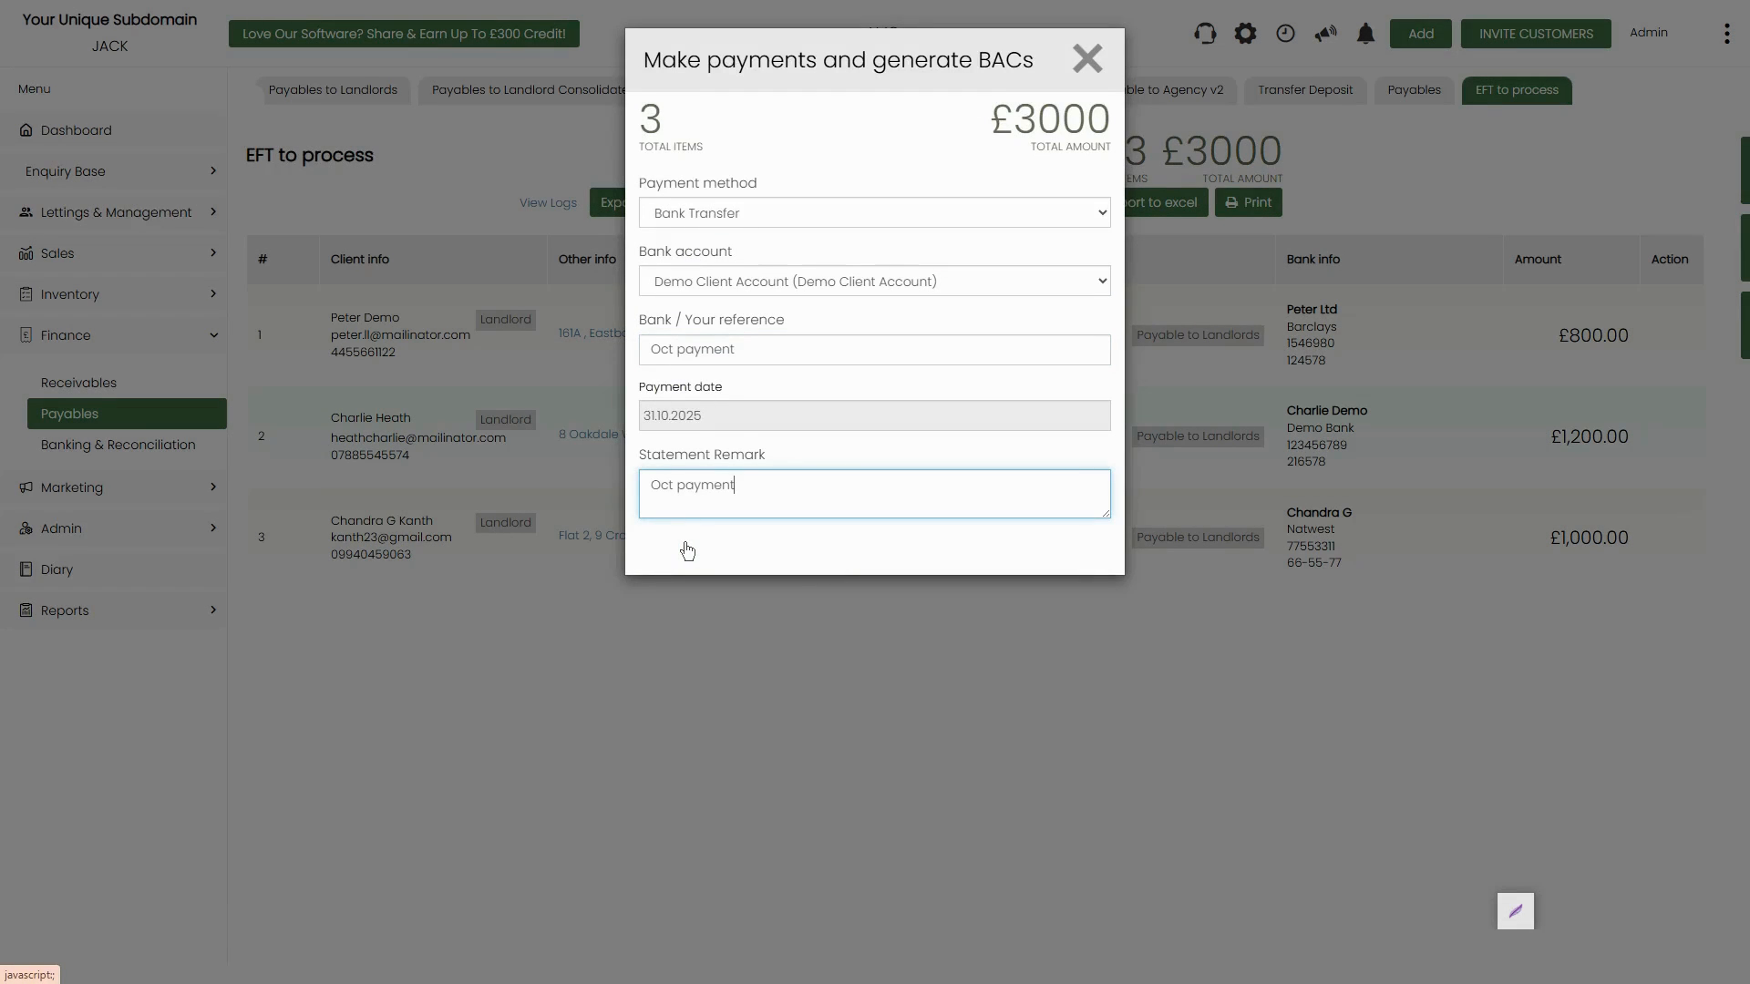

*Figure 5: Make payments and Generate BACs dialog — confirm payment method, bank account, reference, date, and remark before processing*

Fill in the Payment method, Bank account, Bank / Your reference, Payment date, and Statement Remark fields, then confirm. The system will generate a BACs file for download and mark all queued payments as processed.

**📌 Note:** The Exported BACs files button on the EFT to process tab lets you download previously generated BACs files if you need to re-submit or keep a record.

**Step 7: View and Download the Landlord Statement (Remittance Advice)**

After a payment is processed, a remittance advice PDF is generated automatically. To access it, click the Paid Statements tab (visible after payments are recorded) or go to the Paid landlord statements page.

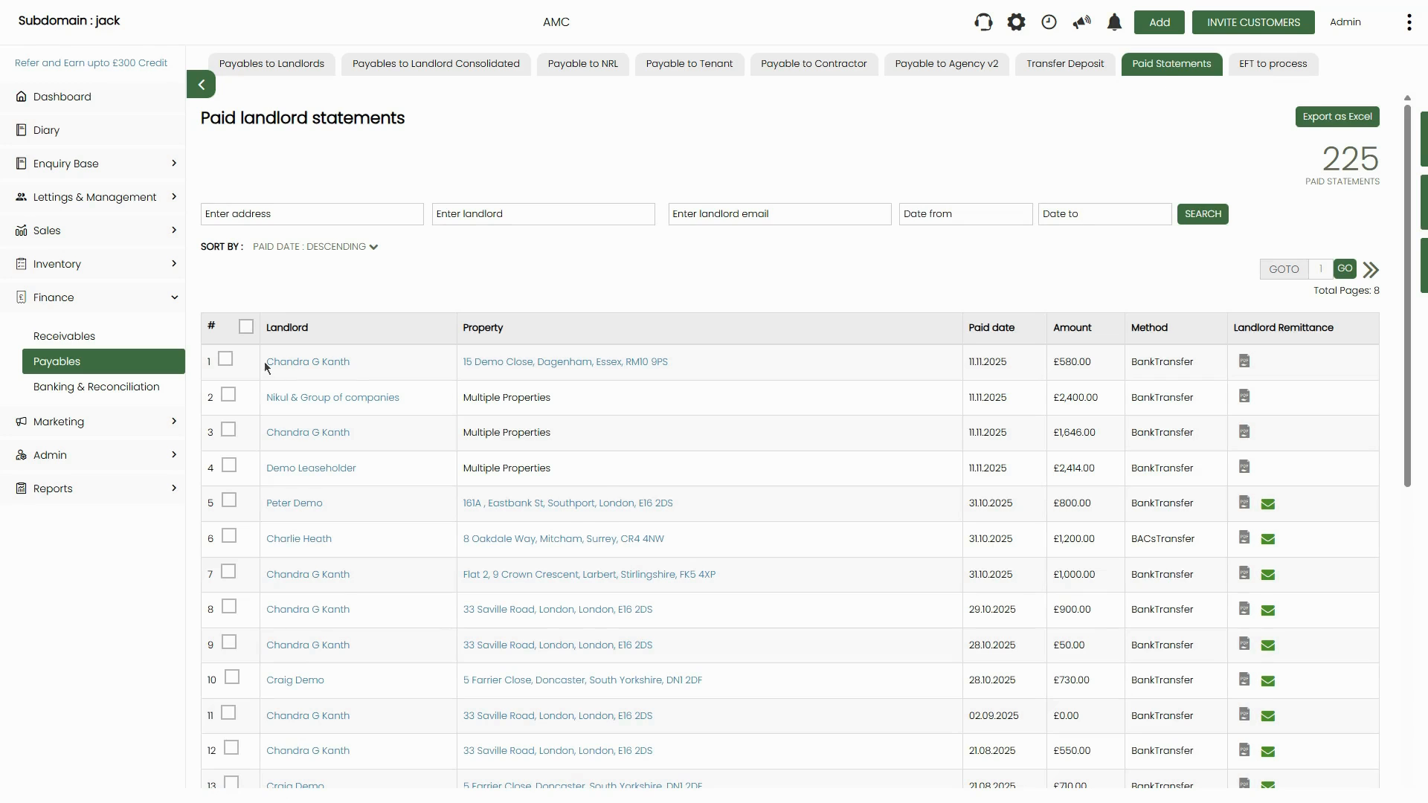

*Figure 6: Paid landlord statements page — all historical payments listed with amounts, method, and remittance PDF links*

Each row in the Paid Statements list has a PDF icon in the Landlord Remittance column. Click it to download the remittance advice for that payment. If the landlord has an email address on file, a green envelope icon will also appear — click it to send the statement directly to the landlord.

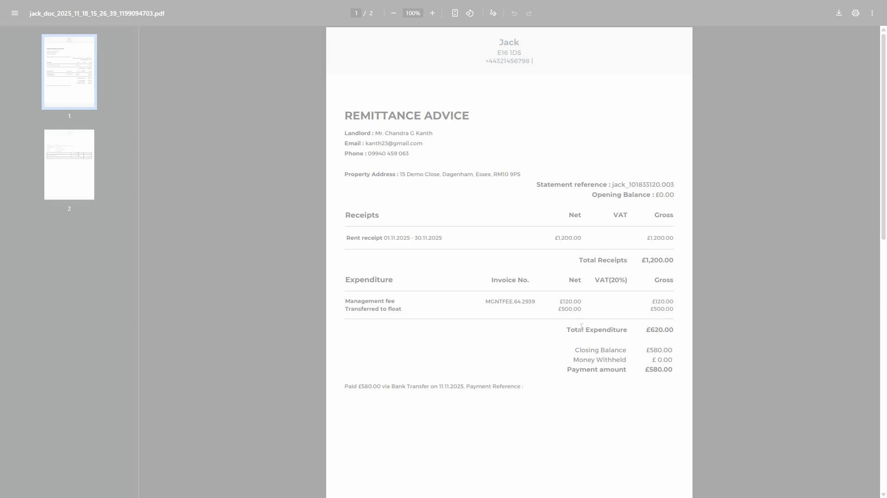

*Figure 7: Sample remittance advice PDF — shows property, rent receipts, management fee, and net payment amount*

**📌 Note:** You can also bulk-send landlord statements from the Paid Statements page. Tick the checkboxes for the statements you want to send and click the Send landlord statement button that appears.

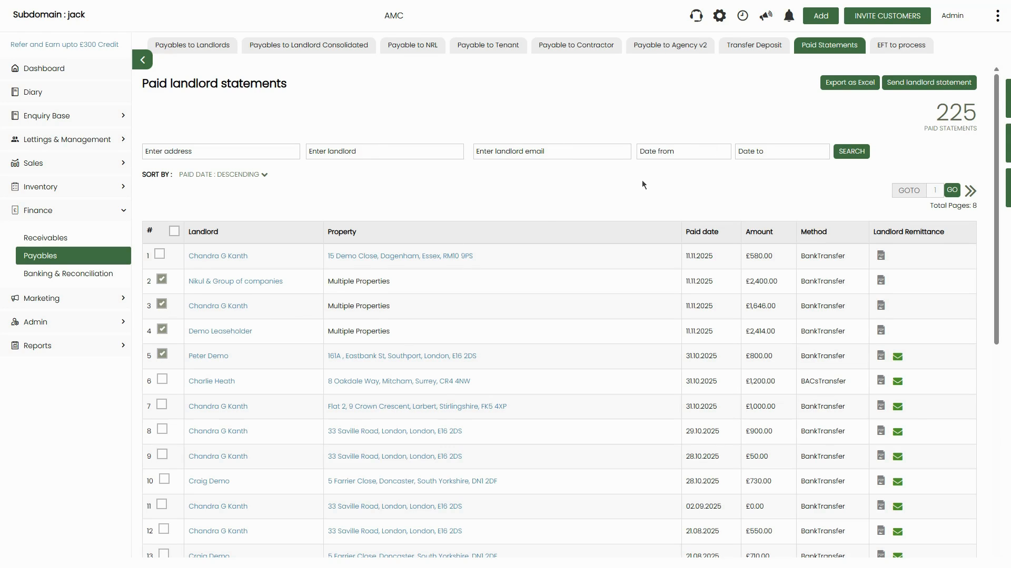

*Figure 8: Bulk-selecting statements — tick rows and use 'Send landlord statement' to email multiple landlords at once*

# **Method 2: Payables to Landlord Consolidated**

Use this method when a landlord has multiple properties and you need to pay all or some of them in one action. The consolidated view groups all properties for a landlord into a single row showing the total payable amount.

**Step 1: Navigate to Payables to Landlord Consolidated**

From the Payables page, click the Payables to Landlord Consolidated tab in the top navigation. This view shows one row per landlord, consolidating all their properties into a single total.

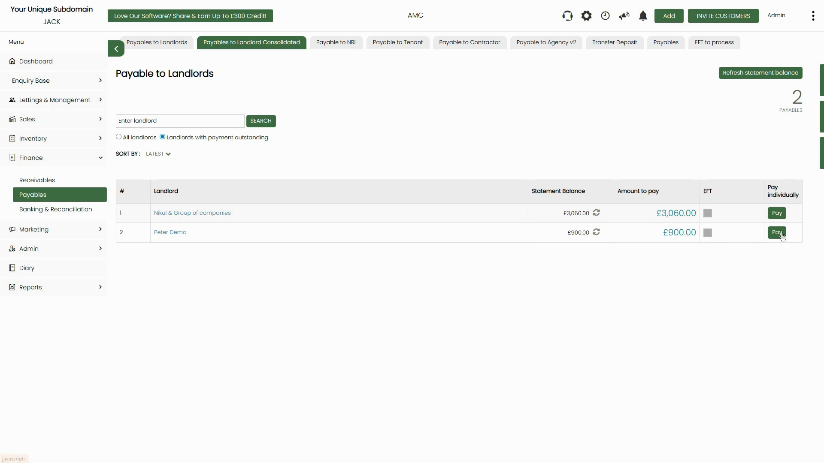

*Figure 9: Payables to Landlord Consolidated tab — each row shows one landlord with their total Statement Balance and Amount to pay*

**Step 2: Click 'Pay' to Open the Pay Landlord Dialog**

Click the green Pay button in the Action column for the relevant landlord. This opens the Pay landlord dialog which shows all individual properties for that landlord on the right side, with the Balance and Amount fields for each one.

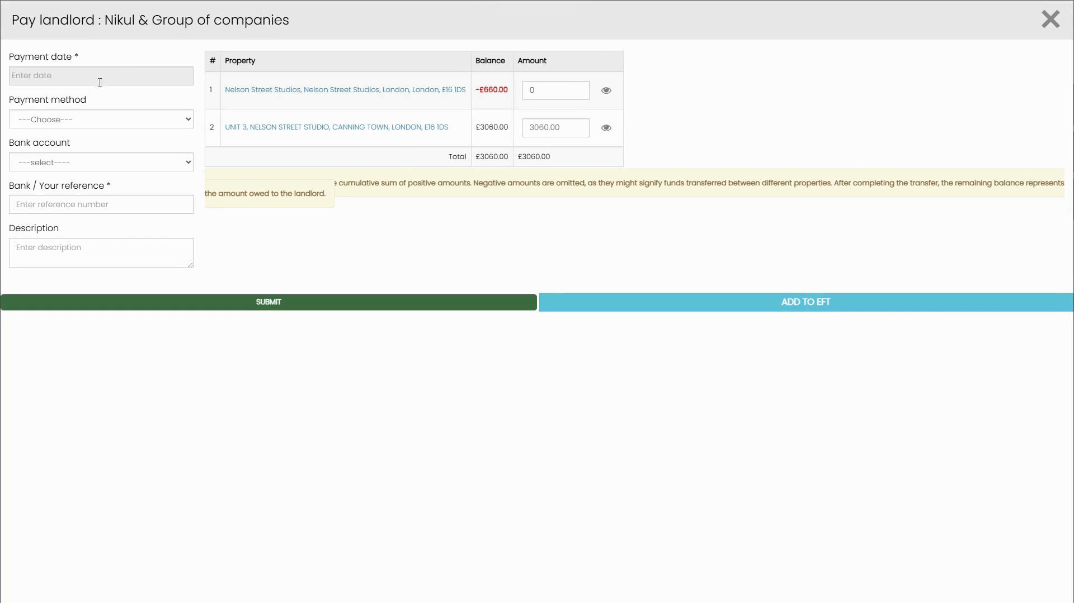

*Figure 10: Pay landlord dialog — left side for payment details, right side shows all properties with individual balances and amount fields*

On the right side, each property is listed with its current Balance and an editable Amount field. The Total at the bottom updates automatically as you adjust amounts. A yellow info box explains that negative amounts (properties where the landlord owes money) are omitted from the total automatically.

**Step 3: Handle Negative Balances Per Property**

If a property shows a negative balance (shown in red, e.g. -£660.00), this means charges or deductions exceed the rent received for that property. The system sets the Amount for that property to 0 by default, but you can click the eye icon next to that row to inspect the breakdown and transfer from another property if needed.

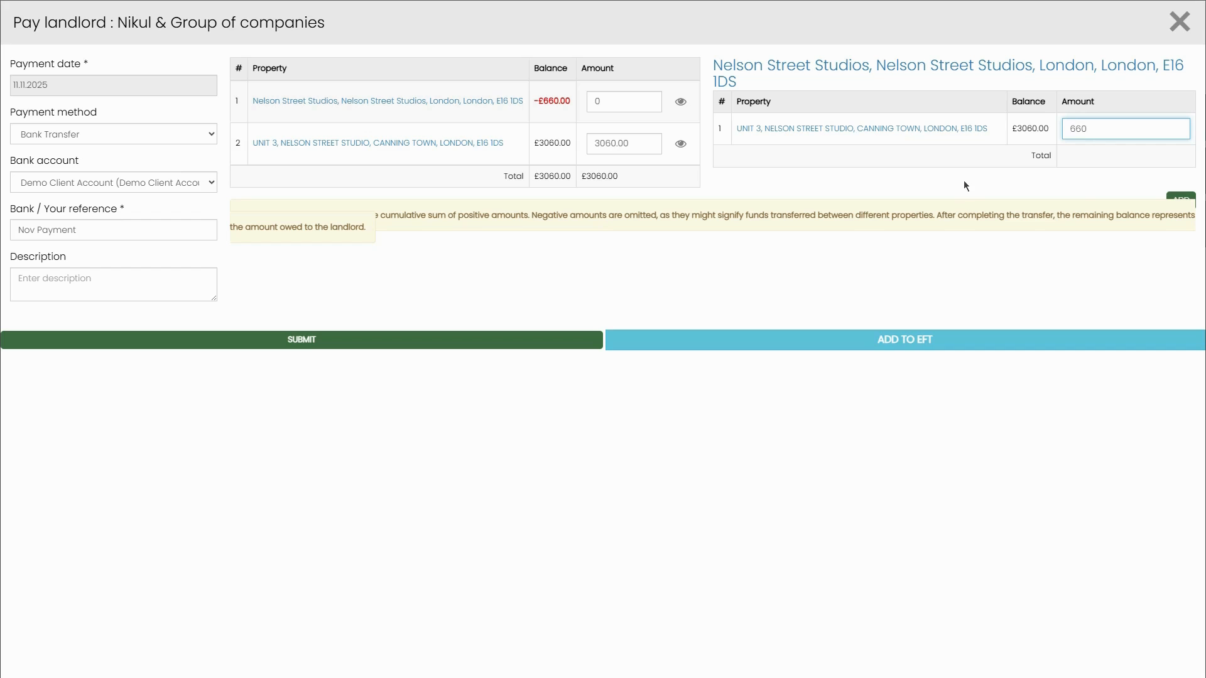

*Figure 11: Property breakdown — clicking the eye icon on a negative-balance property shows the underlying transactions so you can investigate or manually adjust the amount*

**⚠️ Important:** Do not enter a negative number in the Amount field. If a property has a negative balance, leave the Amount as 0 (zero) and investigate the transactions separately before paying.

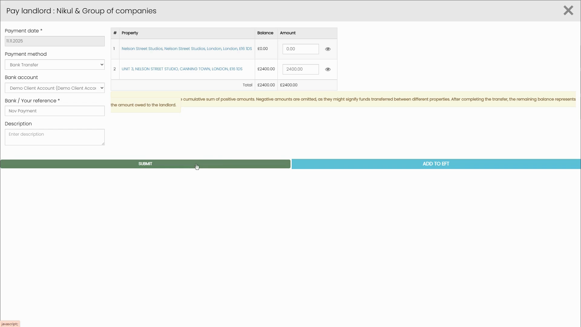

*Figure 12: Adjusted amounts — property 1 (negative balance) set to £0.00, property 2 pays £2,400.00, giving a revised total*

**Step 4: Fill in Payment Details and Submit or Add to EFT**

On the left side of the Pay landlord dialog, complete:

* Payment date – Enter the date the payment is being made.
* Payment method – Select from the dropdown (Bank Transfer, BACs Transfer, Cash, Cheque, Standing Order, Direct Debit, Online Payment, From Holding Deposit).
* Bank account – Select the client account.
* Bank / Your reference – Enter a payment reference.
* Description – Optional internal description.

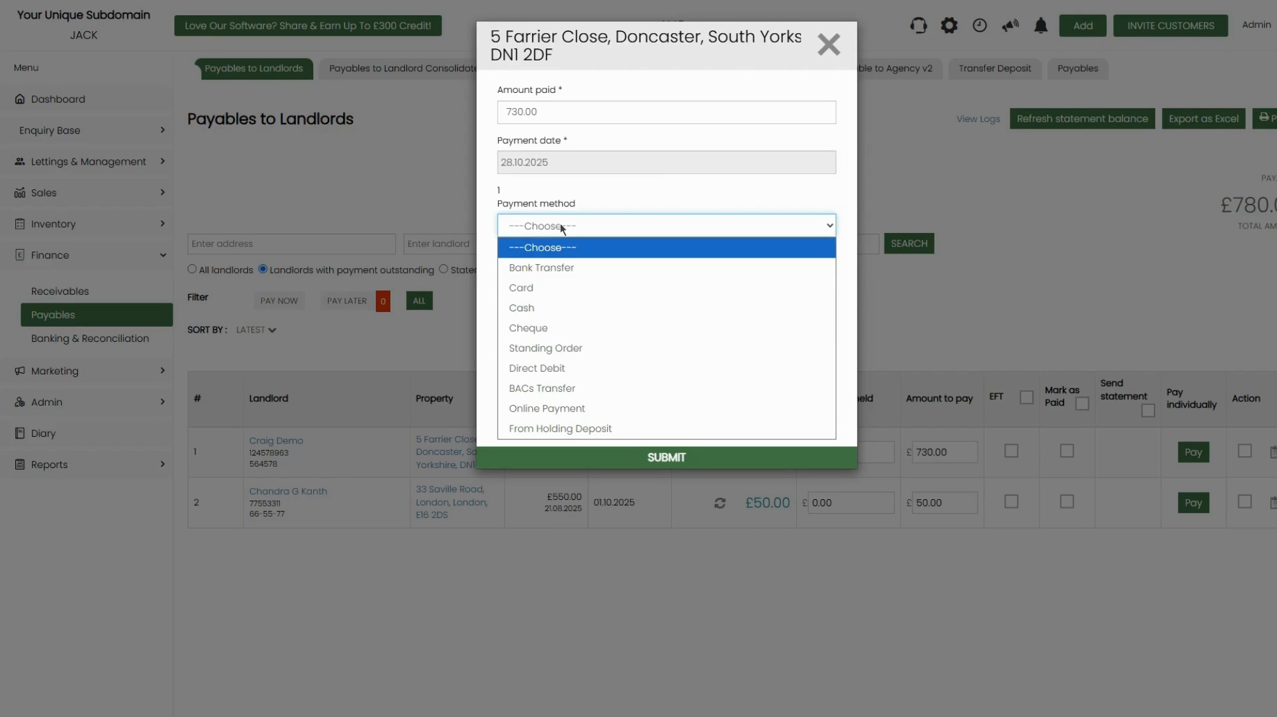

*Figure 13: Payment method dropdown — all available options shown*

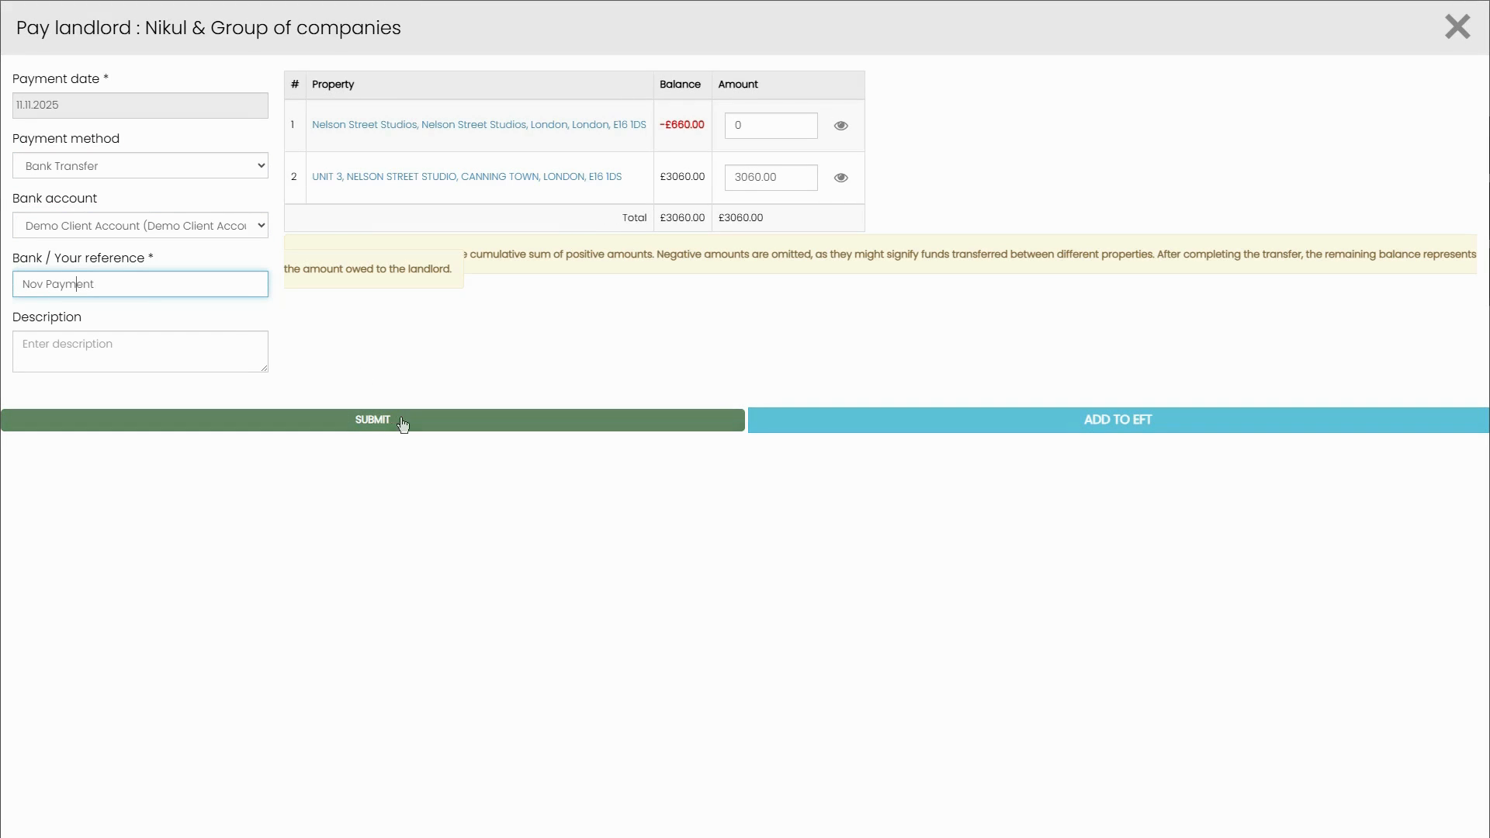

*Figure 14: Completed Pay landlord form ready to submit — payment date, method, bank account, and reference all filled in*

Once the form is complete, click either:

* SUBMIT – Records the payment immediately.
* ADD TO EFT – Adds the payment to the EFT queue for batch BACs processing (same queue as Method 1).

**📌 Note:** If you click ADD TO EFT, the payment will appear in the EFT to process tab. You will still need to go to that tab and click Make payments and Generate BACs to finalise the BACs file.

# **Quick Reference Summary**

|  | **Method 1: Payables to Landlords** | **Method 2: Payables to Landlord Consolidated** |
| --- | --- | --- |
| **Where to start** | Finance → Payables → Payables to Landlords | Finance → Payables → Payables to Landlord Consolidated |
| **Best for** | Paying individual landlords, one property per row | Landlords with multiple properties (grouped view) |
| **Pay action** | Click Pay button → Mark as paid form → Submit | Click Pay individually → Payment form → Submit or Add to EFT |
| **EFT / BACs batch** | Tick EFT checkbox → EFT to process tab → Make payments and Generate BACs | Same: Add to EFT → EFT to process tab |
| **Negative balances** | Not shown by default; filter PAY NOW / PAY LATER | Shown per property; set Amount to 0 to skip |
| **Statements** | Generated as PDF remittance advice after payment | Same: Download PDF from Paid Statements tab |
| **Send to landlord** | Tick Send statement checkbox before paying | Same: use Send landlord statement button on Paid Statements |